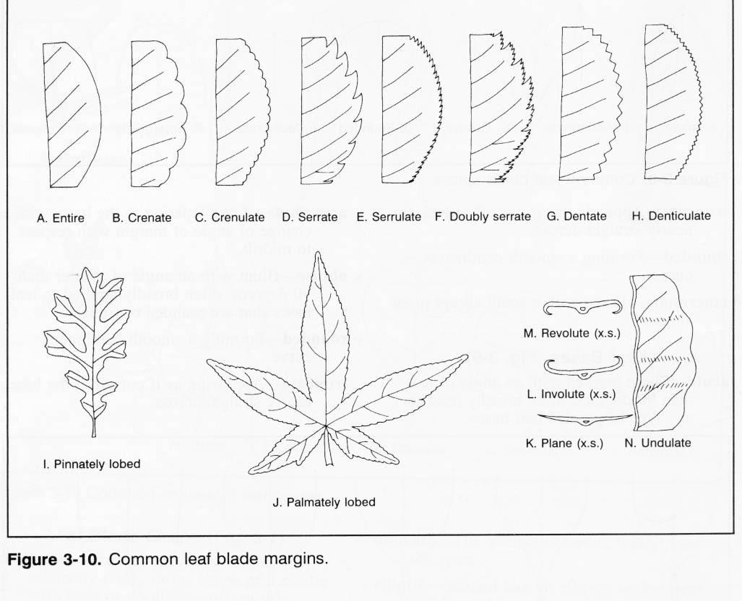IT HAS A _________________ MARGIN.

SERRATE

ENTIRE

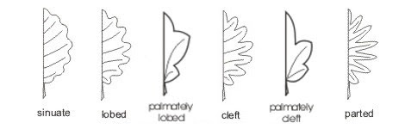DENTATE

LOBED

IT IS______________ .

RED

ORANGE

YELLOW

BROWN

GREEN